**Basic Linux Commands Assignments**

**Assignment Part 3**

Playing with files

1. Create a file like nano file1.txt

o Edit some data and then save the file

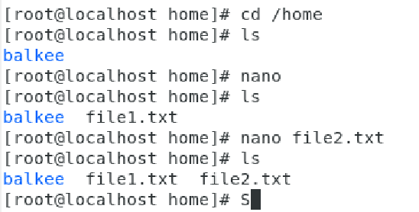

Have created a file under home directory like nano and then gave some data in it.

To save it I just pressed ctrl+x and gave file name as file1.txt then pressed Y button to save it.

I created one more file using the command nano file2.txt and pressed ctrl+x and pressed Y

button to save it.

2. Now we will copy date from file1 to new file2

o cp file1.txt file2.txt

o Then see the output of file2.txt, cat file2.txt

o Give screenshot

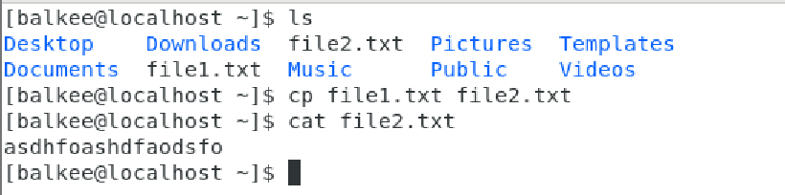

I have created an another file called file2.txt using command touch file2.txt and then

copied the content of file1.txt to file2.txt using the command cp file1.txt file2.txt.

Then viewed the content of file2.txt using cat file2.txt.

Successfully copied.

3. Now we will move the file2.txt to new folder /home

o mv file2.txt /home

o Then go to home directory and check ls, file exits or not?

o Given screenshot

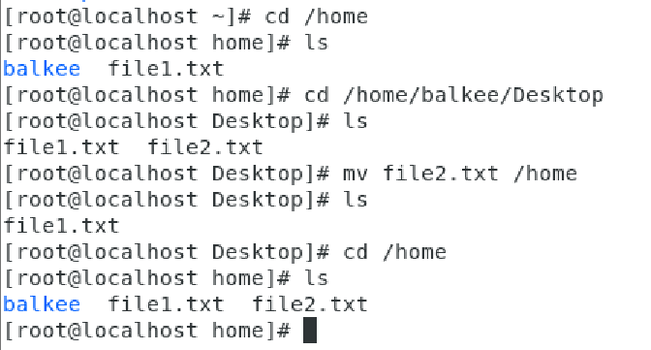

Now moved the file2.txt to the path /home using the command mv file2.txt/home with root account. Unable to move the file without root permission. Then checked the file using ls command and file2.txt found in the path /home.

4. Then we create a new file3.txt and file4.txt in home directory and add

content in it.

o Now do echo “Hello I am newline” > file3.txt and provide the

output of file3.txt

o Now do echo “Hello I am newline” >> file4.txt and provide the

output of file4.txt

o Tell the different between both step you follow and the reason

behind it

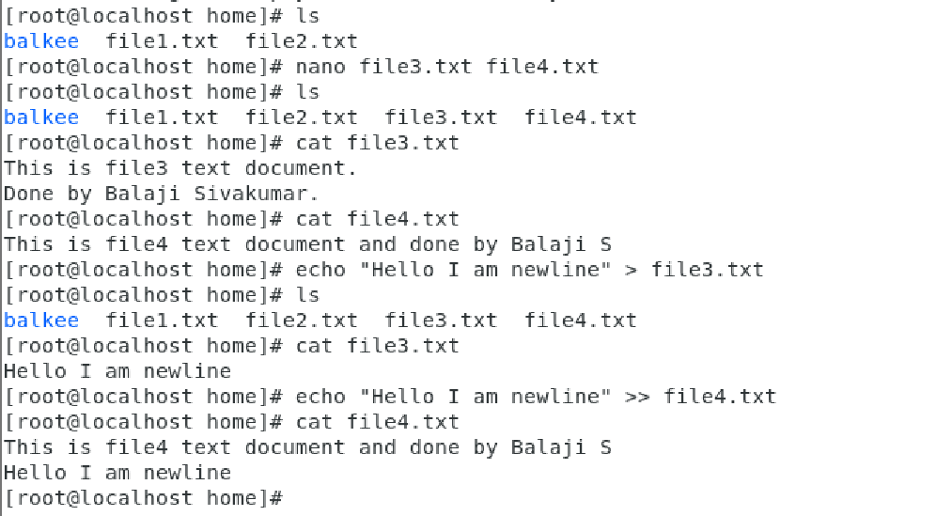

As told, we have created a new file3 and file4 in home directory and added contents using nano

command. Then cat command to see the content in it. Then echo with > (single greater than symbol)

and it deletes the previous one and pasting the new line.

But tried the next one echo with >> ( two greater than symbol) and it adds the new line in the previous content.

5. For remove a file or directory you can use the below two commands

o To delete a file – rm <any_filename>

o To delete a directory - rmdir <any_directoryname>

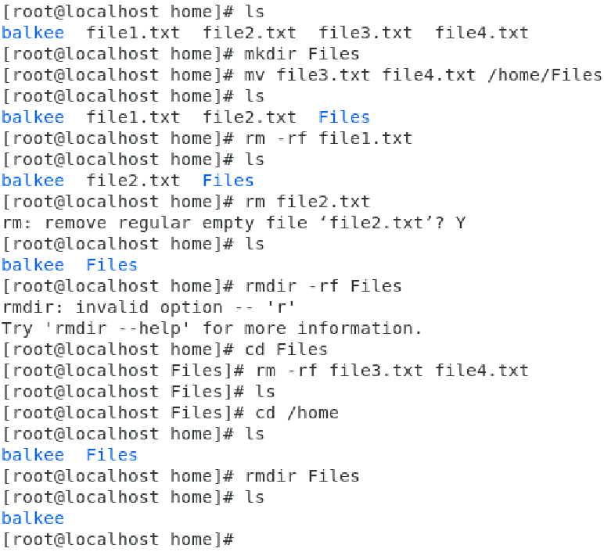

Have tried rm and rmdir command with the 4 files in /home directory and understood the

concept. Have used rm -rf command with the files to delete without asking Yes or No and It is simple but

a powerful command especially when used with options such as -rf which allow it to delete non-empty

directories forcefully.

And also used rmdir<anydirectory_name> for deleting empty directory and working good.

---------------------x-----------------------------x---------------------------